**Security: Data Masking in MySQL 8.0 server**

Data security plays a major role in current age. Privacy matters a lot. Data masking is one of the Key Features when comes to security.

* In MySQL community versions if you want to mask your data, you can go with a Maxscale load balancer.
* They introduced a new masking filter on the Maxscale 2.1 version.
* In MySQL 8.0 Enterprise they have introduced a new security feature called data masking.
* This feature was introduced in MySQL 8.0.13 Enterprise Edition and it provides data masking and de-identification capabilities

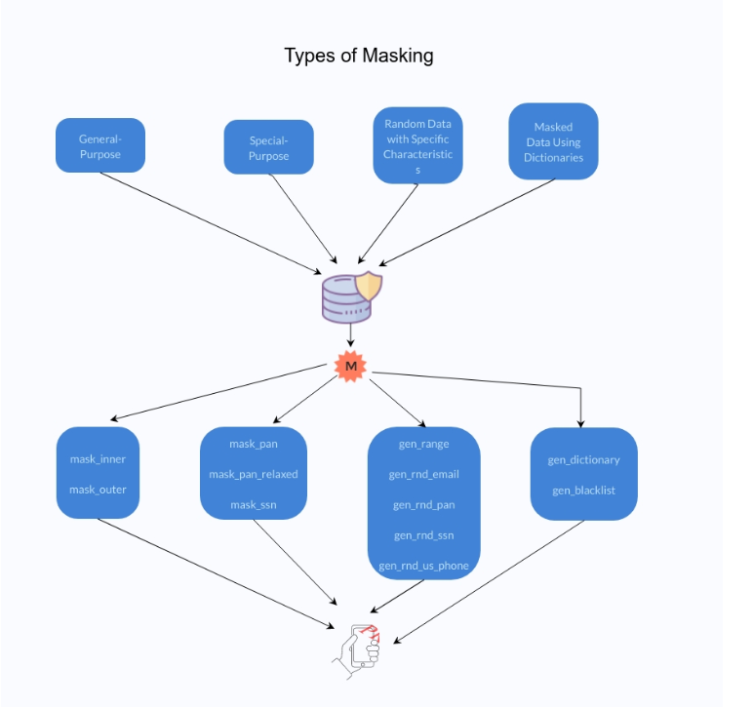

**Read More:**

<https://mydbops.wordpress.com/2020/03/29/securing-mysql-8-0-data-masking-in-server/>

**Data Masking in MySQL (example tutorial)**

<https://dev.mysql.com/blog-archive/data-masking-in-mysql/>

# Sensitive Data Masking with MariaDB MaxScale

[**https://mariadb.com/resources/blog/sensitive-data-masking-with-mariadb-maxscale/**](https://mariadb.com/resources/blog/sensitive-data-masking-with-mariadb-maxscale/)

For details on how to setup the rules, please see [MariaDB MaxScale masking filter guide](https://mariadb.com/kb/en/mariadb-enterprise/masking/).

**MariaDB MaxScale**

[**https://mariadb.com/docs/products/mariadb-maxscale/**](https://mariadb.com/docs/products/mariadb-maxscale/)